**Ex No: 1**

**Date:**

**STUDY OF SYSTEM ADMINISTRATION AND NETWORK ADMINISTRATION**

**Aim:**

A private organization appoints a system administrator and network administrator for troubleshooting and maintenance. System administrator focuses on servers and computer systems, while network administrators work more specifically with network-related tasks and equipment. Becoming a system administrator/network administrator will entail learning some specialized skills. Elucidate the roles and responsibilities & skill sets of a System administrator / Network administrator.

**Theory:**

## System administrator:

System administrator, or sysadmin, is a person who is responsible for the upkeep, configuration, and reliable operation of computer systems; especially multi-user computers, such as servers. The system administrator seeks to ensure that the uptime, performance, resources, and security of the computers he or she manages meet the needs of the users, without exceeding the budget.

## Skills:

* Entails a knowledge of operating systems and applications
* Problem solving Technique.
* To understand the behavior of software in order to deploy it and for troubleshooting problem.

## Responsibilities of the System Administrator:

* User account management,
* Hardware management
* Perform file system backups, restores
* Install and configure new software and services
* Keep systems and services operating
* Monitor system and network, Troubleshoot problems
* Maintain documentation
* Audit security, Help users,
* Performance tuning.

## Network administration:

A network administrator, sometimes called a systems administrator, is responsible for keeping an organization’s computer network up to date and running smoothly. Any company or organization that uses multiple computers or software platforms needs a network admin to coordinate the different systems. Network admins will especially be in high demand as companies and organizations invest in newer, faster technology and mobile networks. Growth is also expected in the healthcare industry as the use of information technology increases.

## Responsibilities of the Network Administrator

As a network administrator, the tasks generally fall into the following areas:

* Designing and planning the network
* Setting up the network
* Maintaining the network
* Expanding the network

**Procedure:**

Run the network administrator commands and the system administrator commands in the command prompt.

# **SYSTEM COMMANDS**

**TASKLIST:**

This command is used to Show List of Processes along with Their Name, Process ID and Memory Usage.

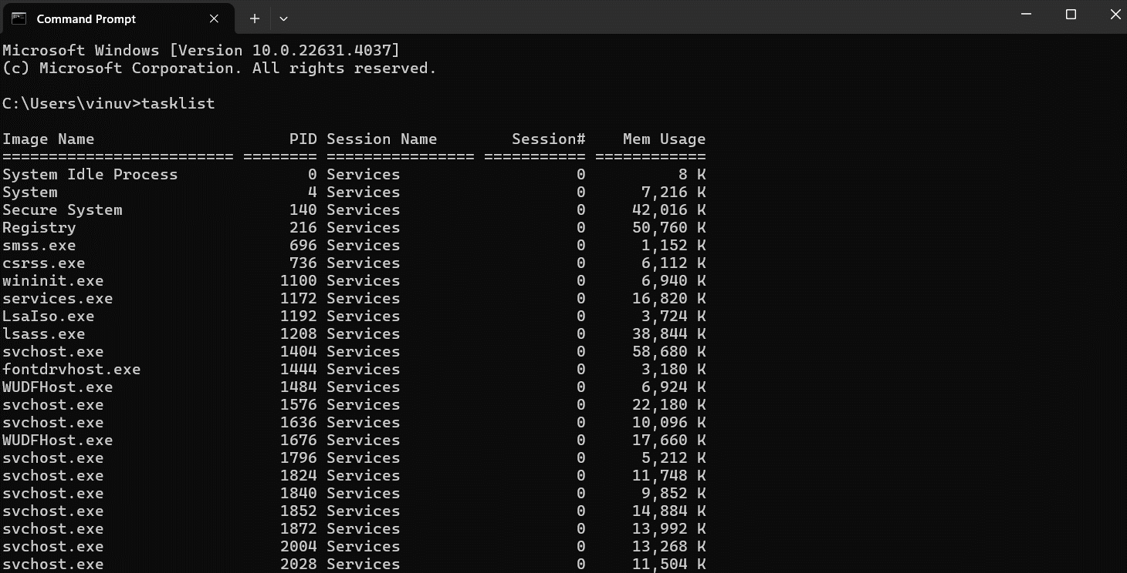**TASKKILL:**

**Eg. taskkill /IM "Notepad.exe" /F**

This command is used to kill the process by its name or PID name.

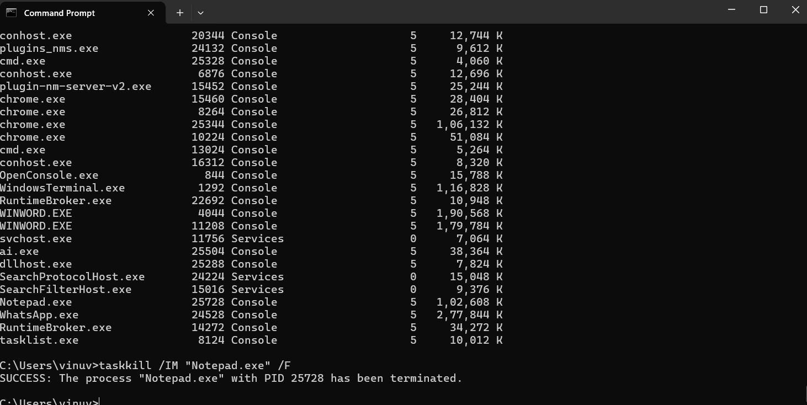

**ATTRIB:**

This command is used to remove and set file attributes (hidden, read-only, system and archive). It displays, sets or removes the read-only, hidden and archive file attributes assigned for a file or directory. It allows a user to change the file attribute directly using this command.

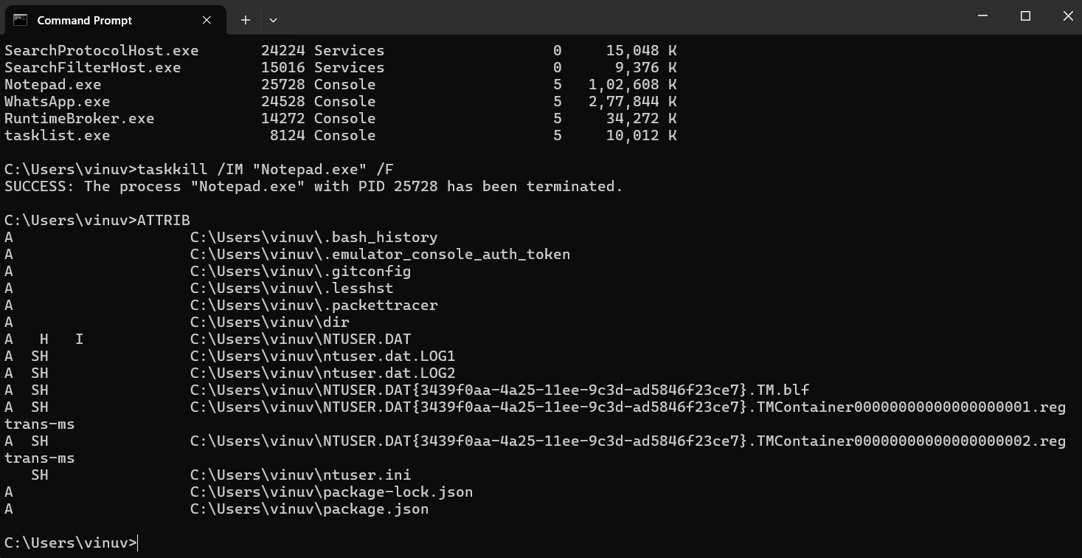

**DRIVERQUERY:**

Used to Display the List of Drivers installed on the System with Given Name, Date and Time.

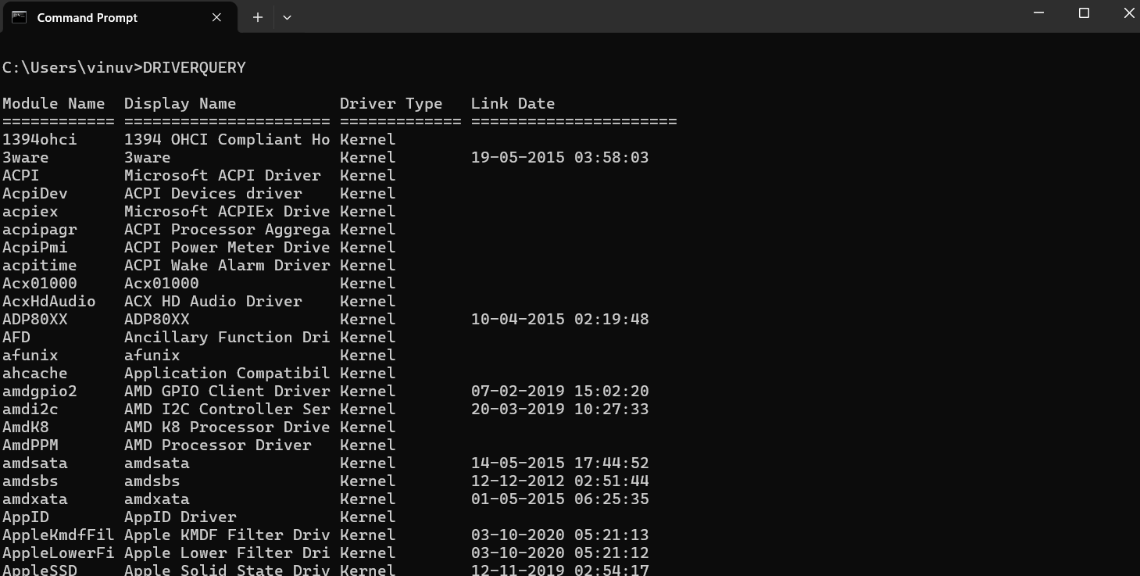

**WHOAMI:**

“whoami” command will help you to check the user details of logged in user and the group it belongs to.



**ASSOC:**

assoc is a command that displays the program and/or functionality associated with a specific file type.

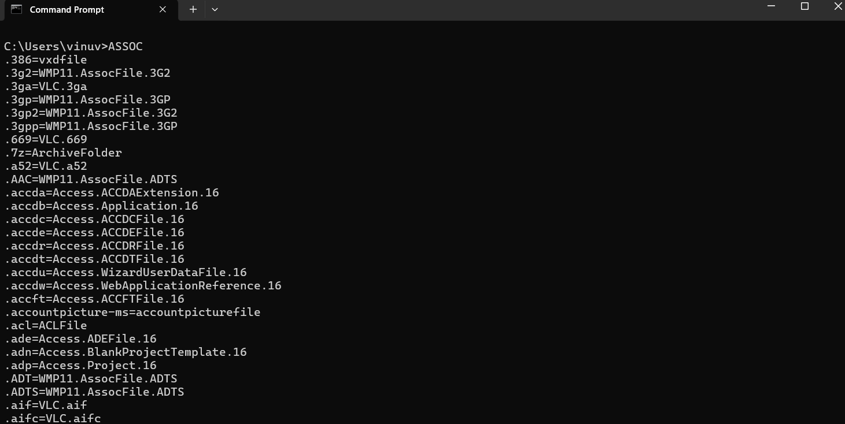

**POWERCFG –ENERGY:**

This command is used to check battery health and generate Energy Report in Windows.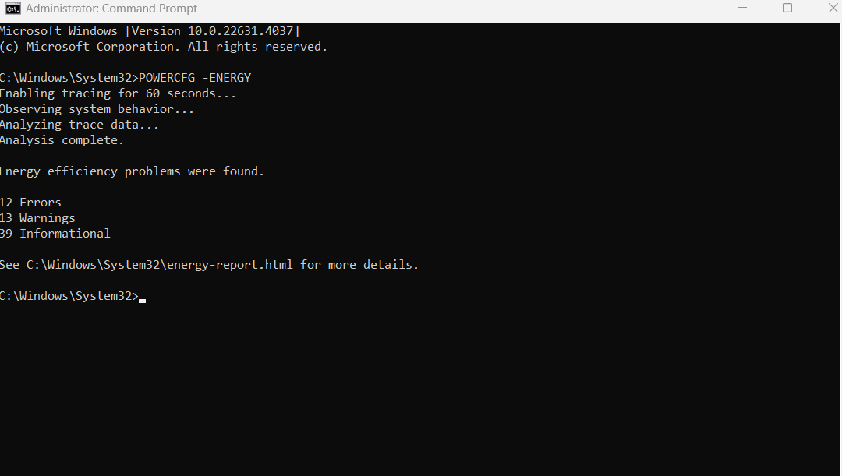

**SYSTEMINFO**

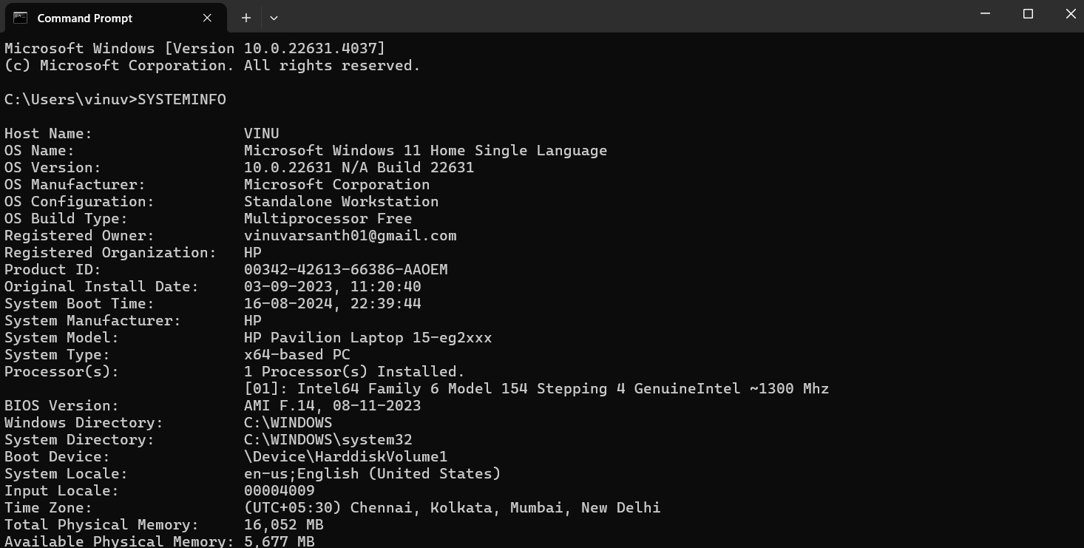

**SYSTEMINFO | FINDSTR /C:"Memory":**

This command easily displays the total amount of memory which is on your system.

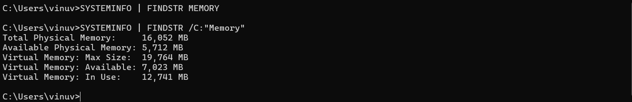

**SYSTEMINFO \FINDSTR BOOT:**

Systeminfo "System Boot Time" gives the time of the last reboot, not the last cold startup as I believe it used to do.



**NET USER:**

The net user command is used to add, remove, and make changes to the **user** accounts on a computer.

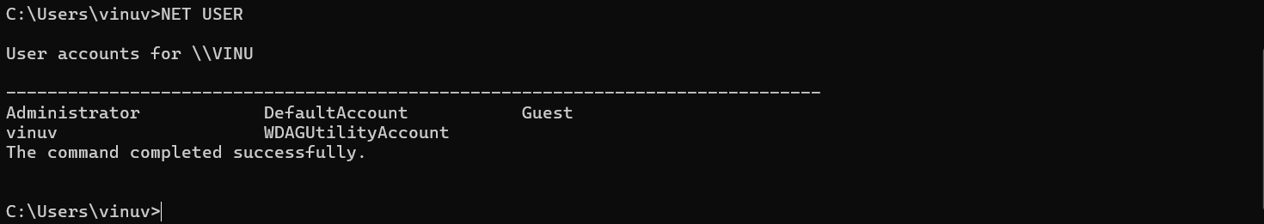

**WMIC CPU:**

**Eg. wmic cpu/?**

The Windows Management Instrumentation Command line (WMIC) is a software utility that allows users to perform Windows Management Instrumentation (WMI) operations with a command prompt.

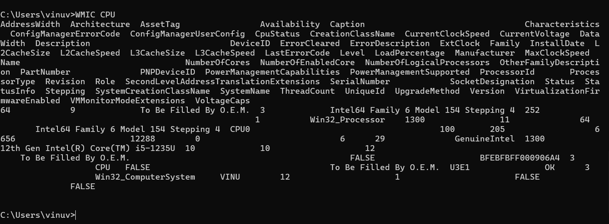

# **NETWORK COMMANDS**

**NETSH**

1. **NETSH TRACE START CAPTURE=YES**

capture =yes (ensures network trace is captured) persistent =yes (specifies whether the tracing session continues across reboots, and is on until netsh trace stop is issued)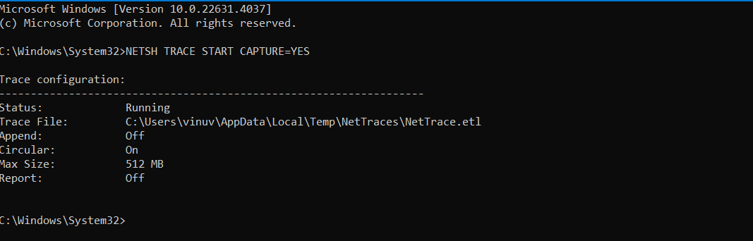

**ii) NETSH TRACE STOP**

This command line tool has a trace feature. To run it, open an elevated command prompt and type netsh. Then the netsh prompt appears. To start the capture type “trace start <parameters>”, please find more details about the parameters and some examples below. To stop the capture, type “trace stop”.

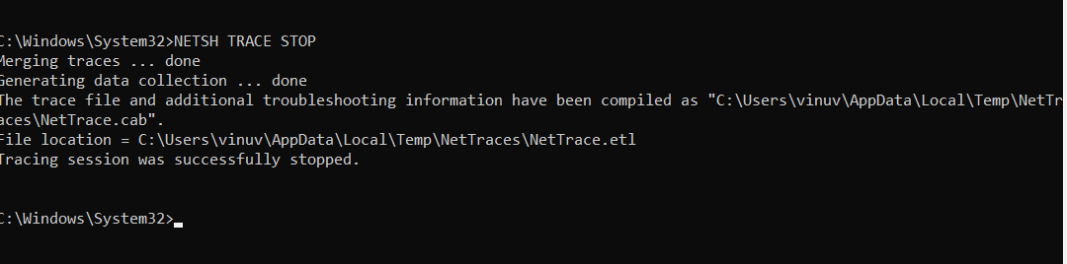

**IPCONFIG:**

This command allows you to get the IP address information of a Windows computer. It also allows some control over your network adapters, IP addresses (DHCP-assigned specifically), even your DNS cache. Ipconfig replaced the older winipcfg utility.

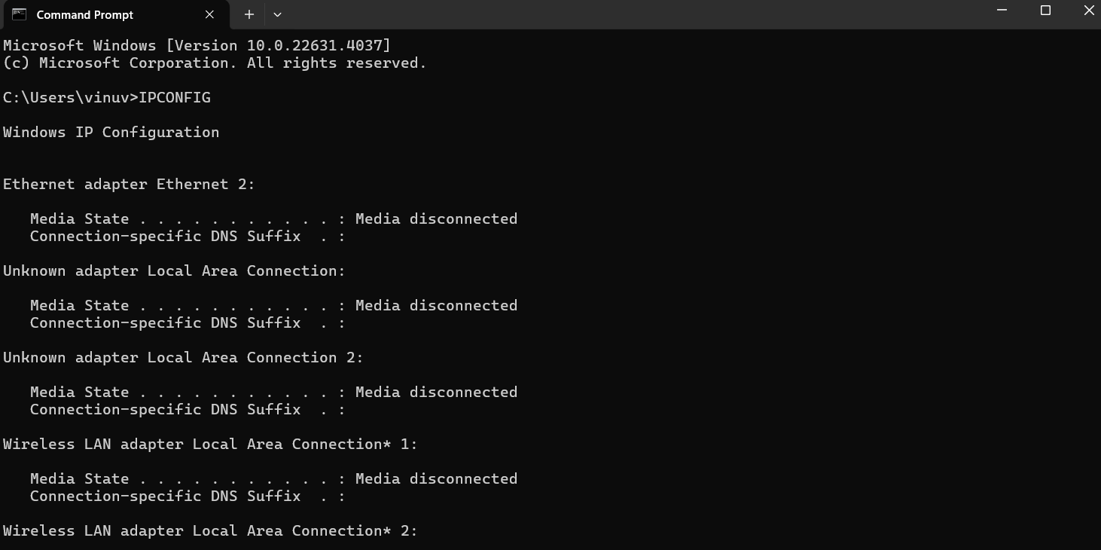

**IPCONFIG /ALL:**

By Using the ‘ipconfig /all’ command, we can see an increased amount of information namely each NIC’s DHCP configuration and the DNS servers.

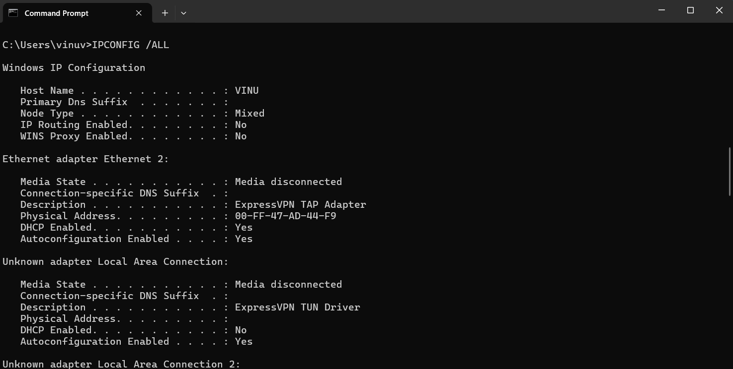

**PING:**

ping is the primary TCP/IP command used to troubleshoot connectivity, reachability, and name resolution. Used without parameters, this command displays Help content. You can also use this command to test both the computer name and the IP address of the computer.

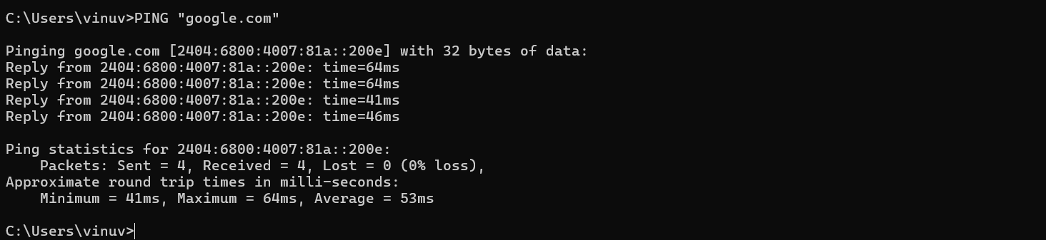

**PING "WEBSITE-NAME"** ***Note: "Website-name"- Give any website name:***

**Eg. Ping google.com**

# **TRACERT:**

The tracert command (spelled traceroute in Unix/Linux implementations) is one of the key diagnostic tools for TCP/IP. It displays a list of all the routers that a packet must go through to get from the computer where tracert is run to any other computer on the

Internet.

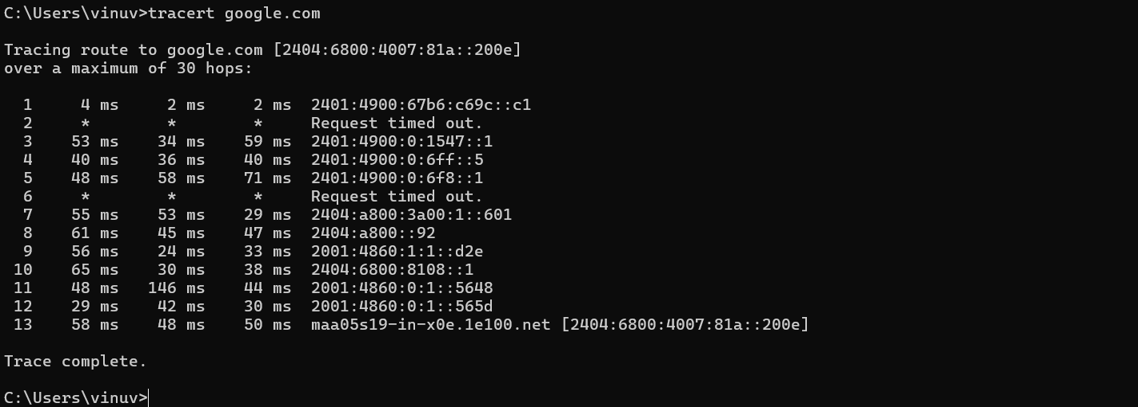

**tracert "WEBSITE-NAME"**

**Eg. tracert google.com**

# **PATHPING (PING AND TRACERT)**

# **HOSTNAME:**

This command is used to display the IP address of the remote machine.



# **NETSTAT:**

This command displays active TCP connections, ports on which the computer is listening, Ethernet statistics, the IP routing table, IPv4 statistics (for the IP, ICMP, TCP, and UDP protocols), and IPv6 statistics (for the IPv6, ICMPv6, TCP over IPv6, and UDP over IPv6 protocols). Used without parameters, this command displays active TCP connections.

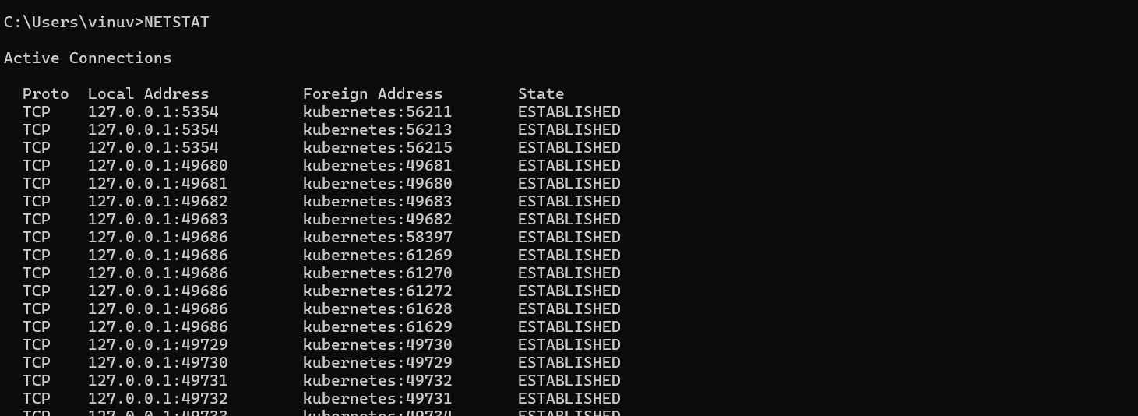

# **NET CONFIG:**

Using net config command we can configure server and workstation services on Windows computer. For server service, we can configure few settings using this command.

Using net config you can change auto disconnect time and hidden attributes.

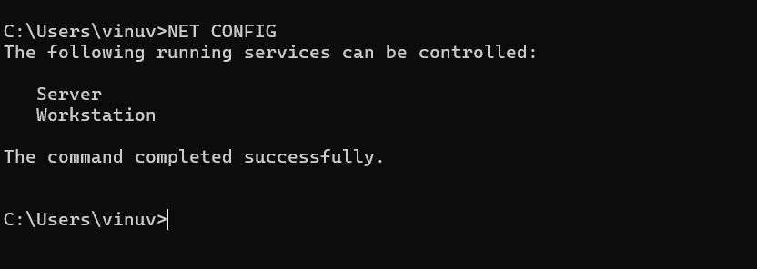

# **NETSTAT –S | FINDSTR ERRORS:**

netstat is a command-line network tool that is a handy troubleshooting command. Its cross-platform utility means you can use it on Linux, macOS, or Windows.

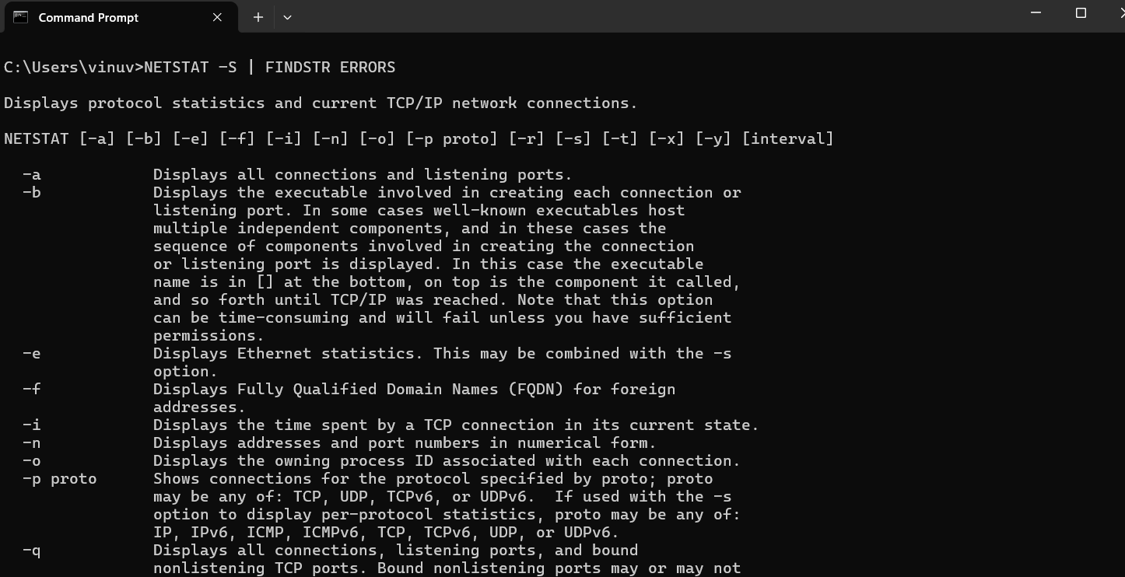

netstat can be very handy in the following.

* + - Display incoming and outgoing network connections
    - Display routing tables
    - Display number of network interfaces
    - Display network protocol statistic

# **NSLOOKUP:**

* nslookup
* nslookup **"WEBSITE-NAME"**

**Eg. nslookup google.com**

Nslookup (from name server lookup) is a network administration command-line tool for querying the Domain Name System (DNS) to obtain the mapping between domain name and IP address, or other DNS records.

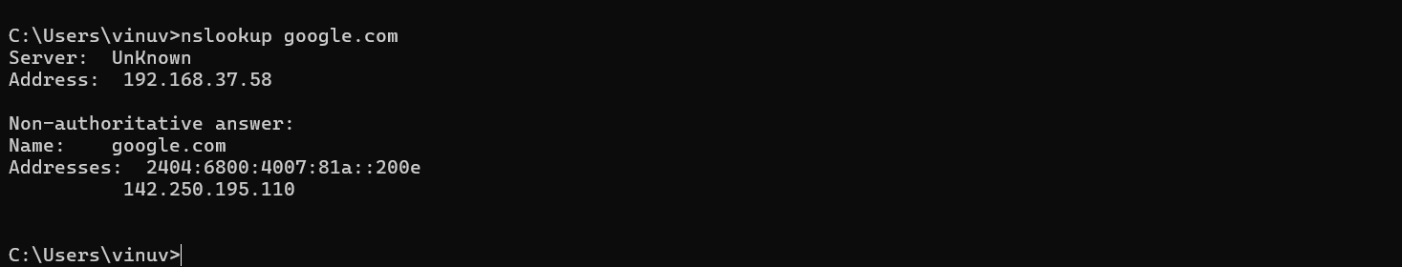

# **ARP:**

arp command manipulates the System's ARP cache. It also allows a complete dump of the ARP cache. ARP stands for Address Resolution Protocol. The primary function of this protocol is to resolve the IP address of a system to its mac address, and hence it works between level 2(Data link layer) and level 3(Network layer).

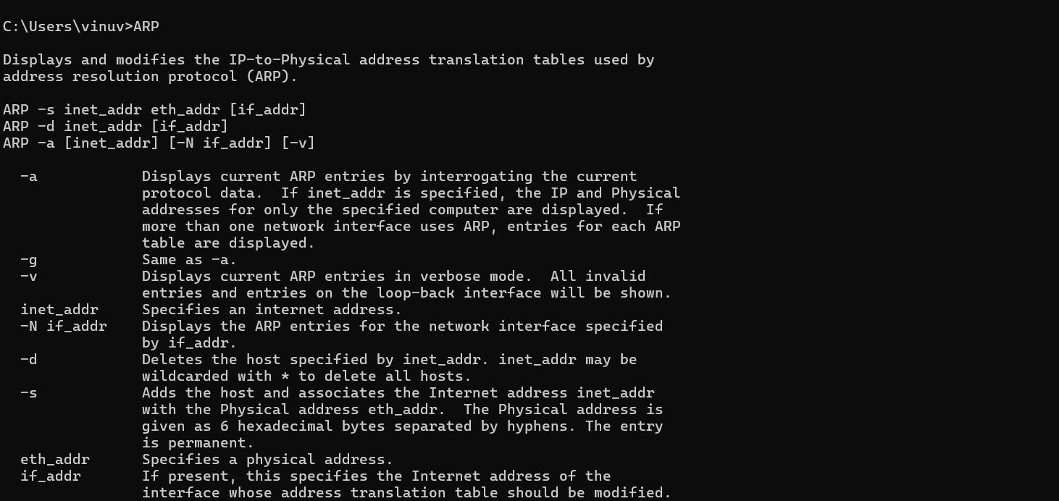

# **GETMAC:**

Getmac is a Windows command used to display the Media Access Control (MAC) addresses for each network adapter in the computer. These activities will show you how to use the getmac command to display MAC addresses.

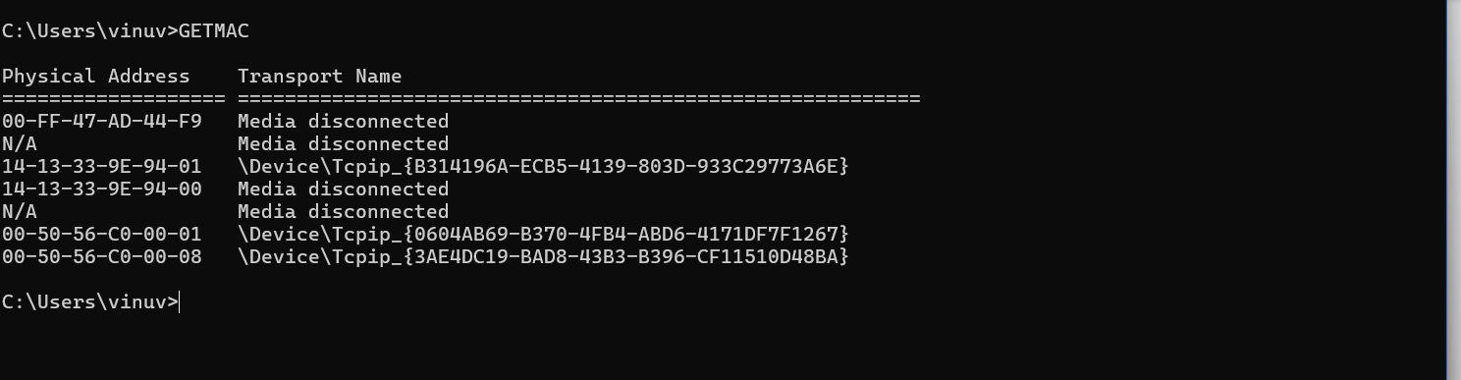

# **ROUTE PRINT:**

The ‘route print’ Command from an Administrative Command Prompt in Windows 7 provides a variety of useful information. Observing the output of the Command indicates there are 5 Major Sections. The Sections include:

Interface List IPv4 Route Table

IPv4 Persistent Routes IPv6 Route Table IPv6 Persistent Routes

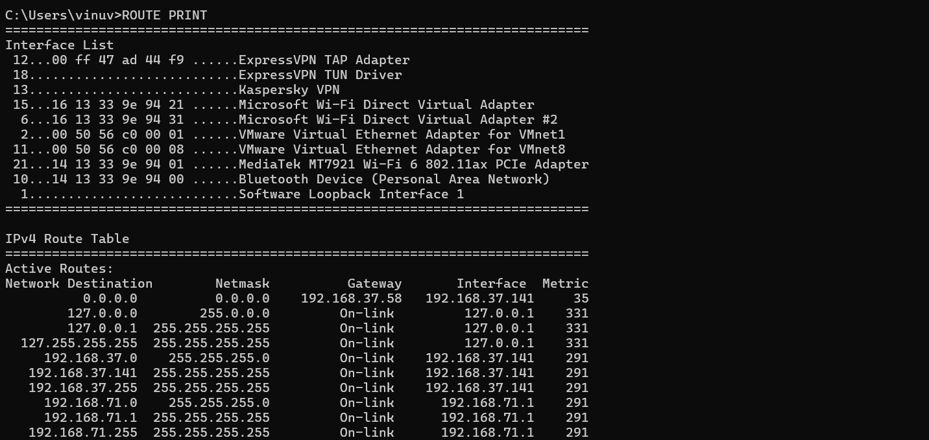

**Result:**

Thus the roles and responsibilities & skill sets of a System administrator / Network administrator were tested through commands in command prompt and studied.